Enroll in Another Course
- Go to www.grtep.com

- Log in using your email address and password.
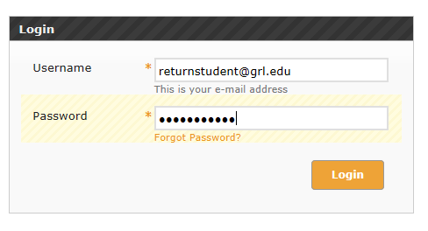
- Go to your Home page. Click Home on your navigation bar on an existing publication.

Or, replace your current URL with https://www.grtep.com/index.cfm/core/User/landingPage.

- Click Enroll In Another Online Publication.

If you have an access code for your new course, follow the steps in the Enroll with an Access Code section. If you don’t have an access code, skip this section and go to the Enroll without an Access Code.
Enroll with an Access Code
- Enter your access code in the Access Code field and click Next.
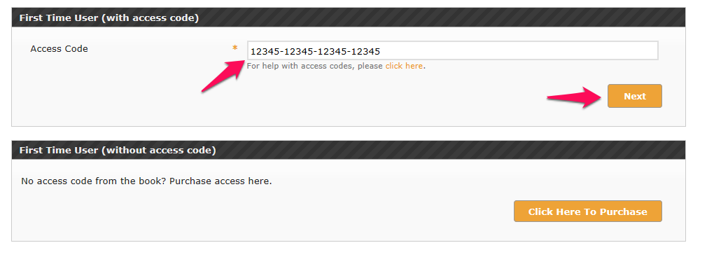
- Select the Institution and the Online Publication. This may have been populated for you.
Click Next to continue.
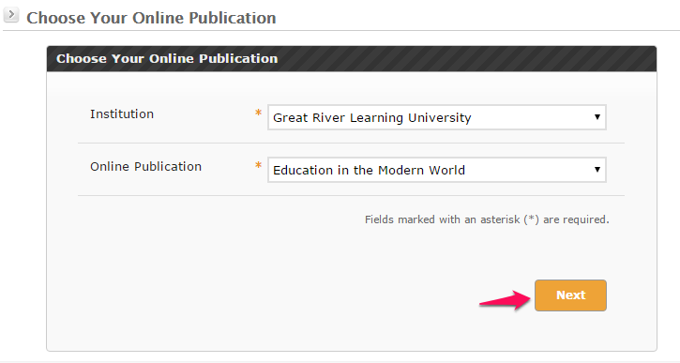
- If the enrollment was successful, you should see a confirmation message like the one below. There may be further steps to perform depending on your course.
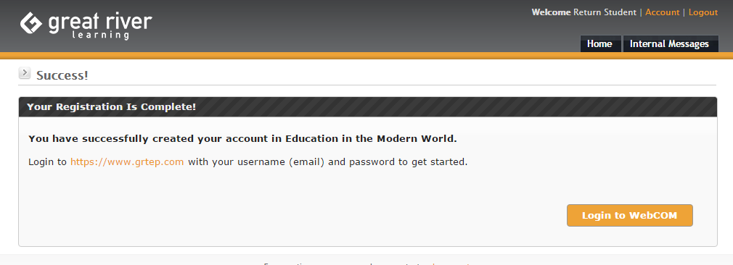
- Click Home to access your new course.
Enroll without an Access Code
- Click on the Click Here To Purchase button.
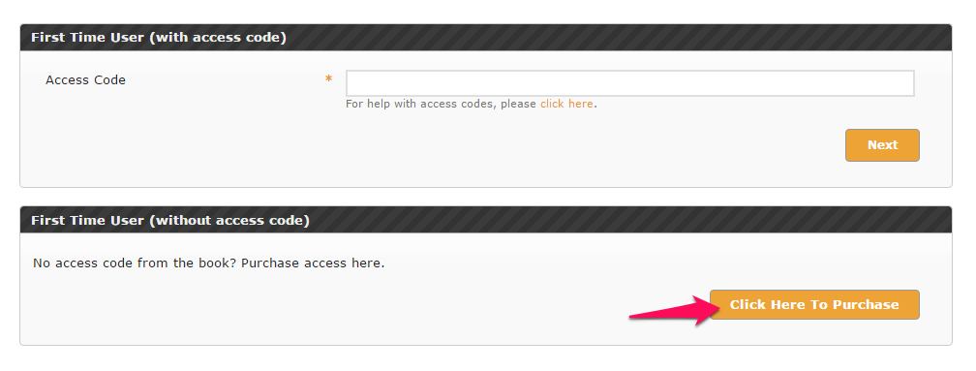

- Select your Institution and Online Publication. Click Next to continue.

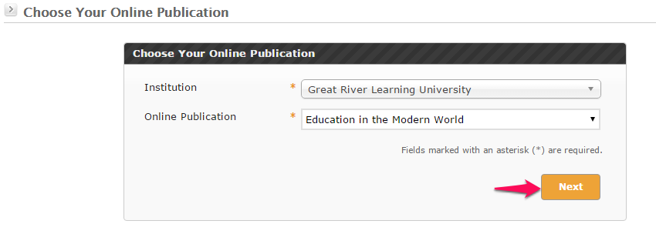

- Verify the correct course has been selected.

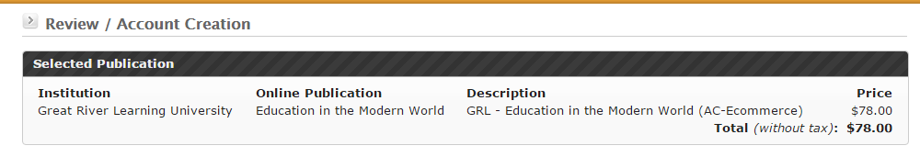

- Verify your Account Info.

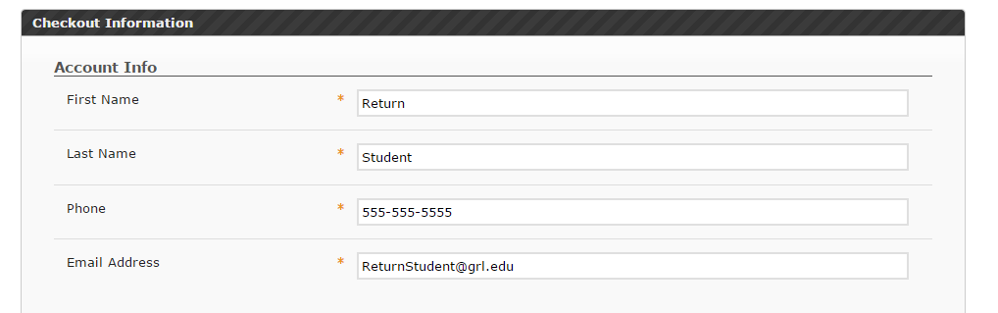

- Verify your Billing Information.

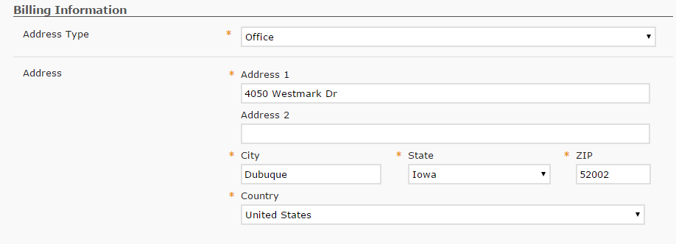

- Enter your Shipping Information. You can check the box at the top of this section to use the same address information as your billing address.

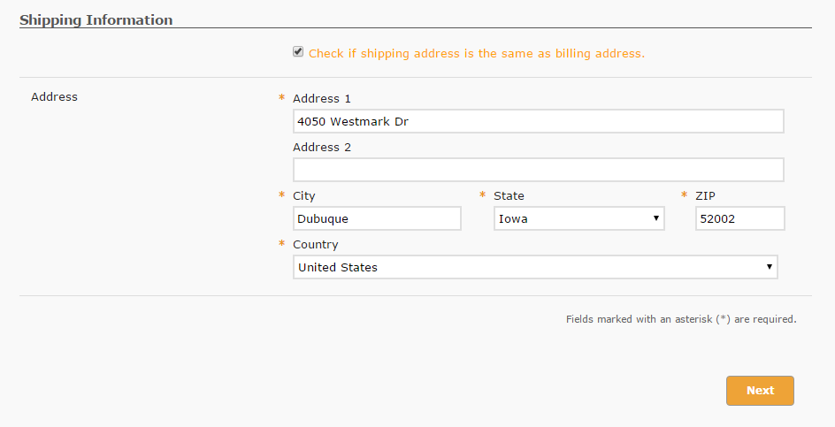

- Click Next to continue.
- Enter your Credit Card Information and click Submit.

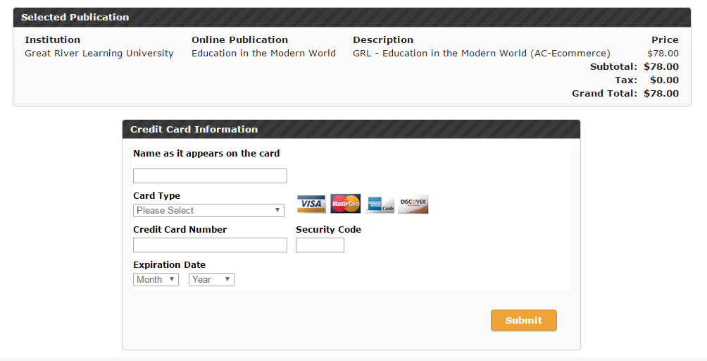

- If the enrollment was successful, you should see a confirmation message like the one below. There may be further steps to perform depending on your course.

- Click Home to access your new course.

